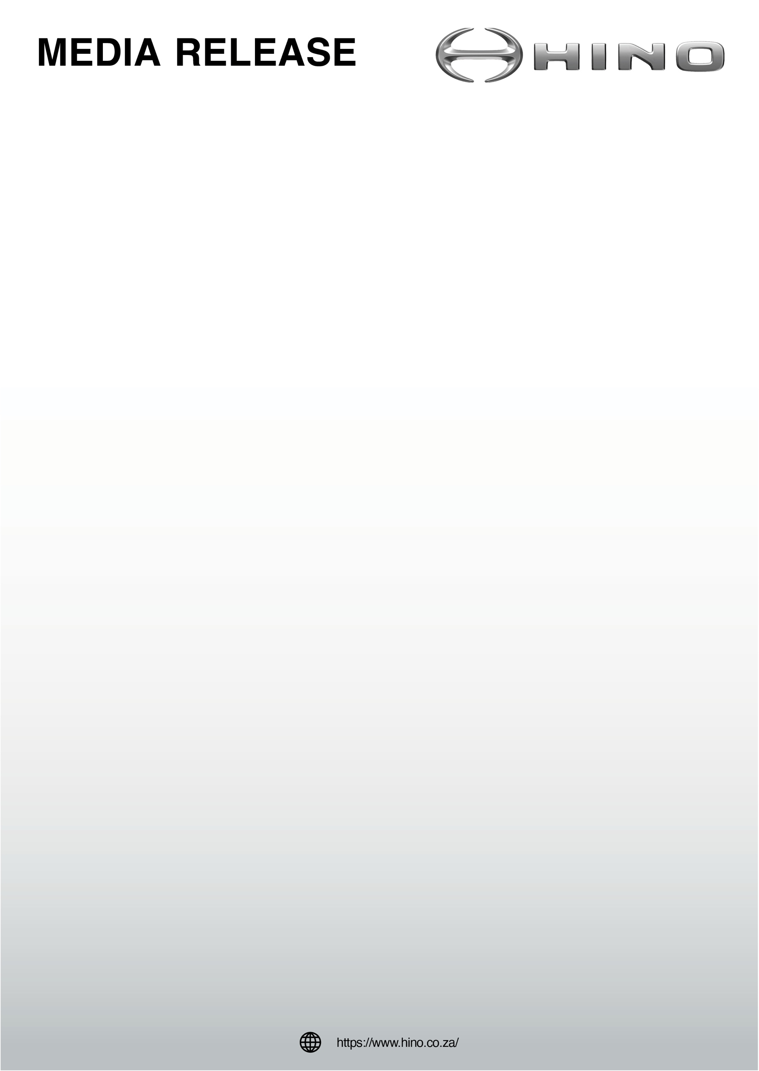

HINO SA DISPLAYS DUAL FUEL TRUCK AT AUTOWEEK IN DURBAN
“We are delighted that the first time we displayed the innovative Hino dual fuel protype truck to the public was at the naamsa I The Automotive Business Council’s SA Auto Week 2026 conference which was held at the Durban Conference Centre from 13-16 November,” says Anton Falck, Vice President of Hino South Africa.
“The conference theme, ‘Transforming Tomorrow Today: Resetting Policy, Advancing the Energy Transition, Driving Investment & Inclusive Growth’, is very apt for the innovative dual fuel Hino truck, which is unique in South Africa in that it uses hydrogen gas and diesel fuel in its engine.
“Participating in an event in Durban was very special for us as this is the birthplace of Hino in South Africa. The first Hino trucks were imported in 1972 and two years later these trucks were being assembled at a plant outside Durban from CKD kits imported from Japan. The number of Hino’s assembled in Durban is now approaching 100 000
ENDS

